**Assignment 16.3**

**Execute Session 16 - Assignment 1 (Machine and Sensor data analysis) using Reduce side join and compare which join is faster in normal conditions**.

**DRIVER Class:**

Use multiple Input paths to get multiple inputs for mapper

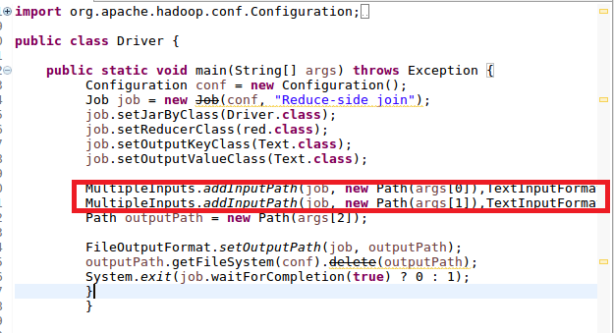

**MAPPER1:**

In mapper 1 sending the BUILDING ID and Country as key and value respectively

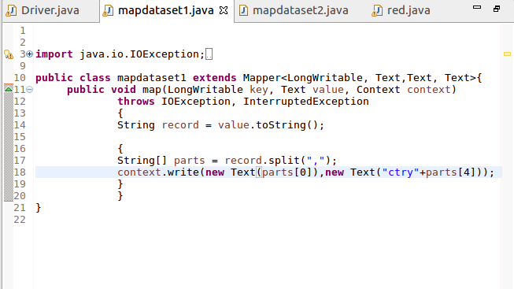

**MAPPER2:**

In this checked for variation (actual temperature not equal to targeted temperature) and then sent building id as “key” and a count of 1 as "value.

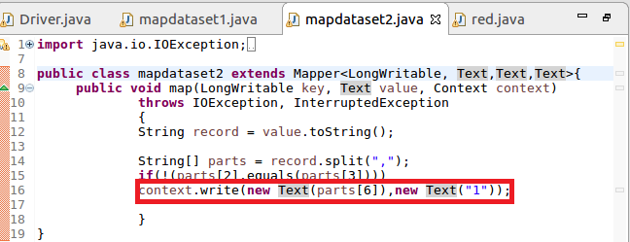

**REDUCER:**

If value matched “ctry ”, we use substring to take the country for a given id else made total count and gave country as “key” and total count as “value”.

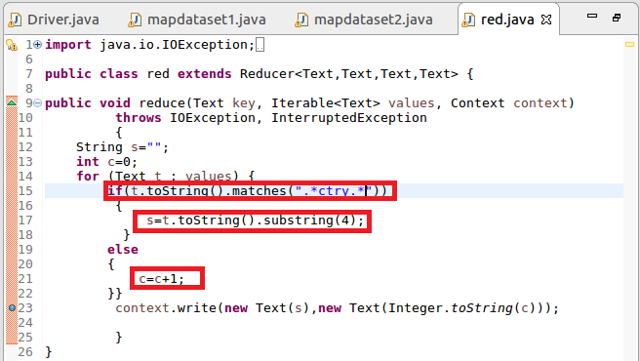

**RUNNING JAR:**

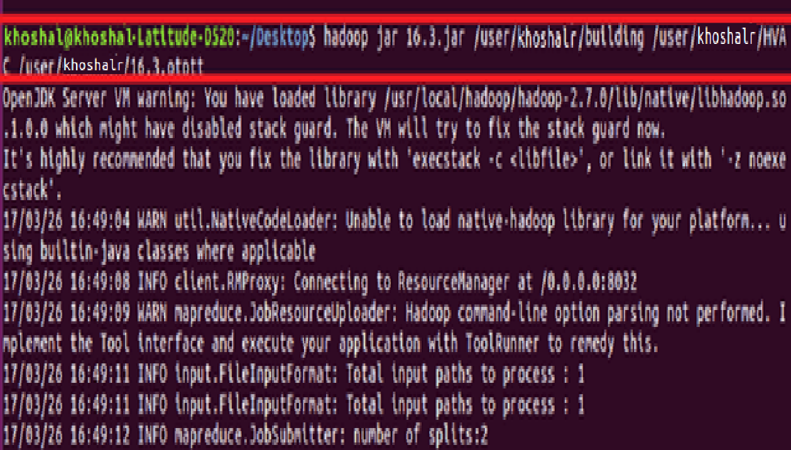



**OUTPUT:**

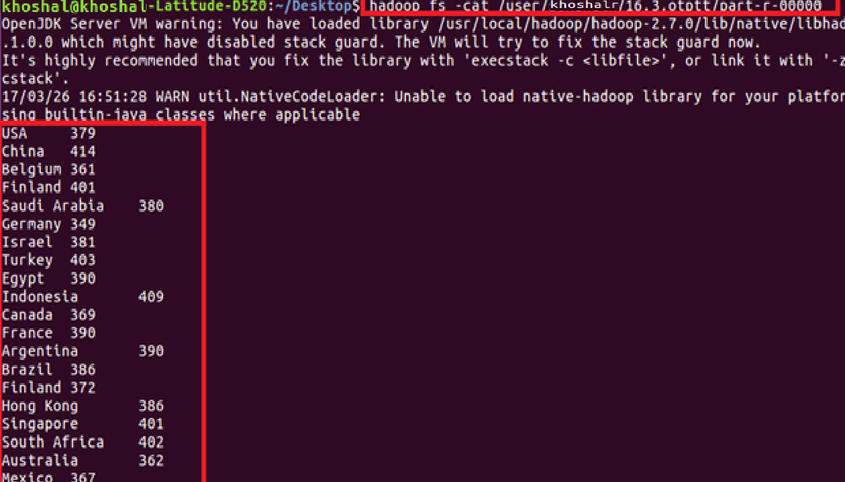

**Comparison:**

Joining the Reduce Side will happen after the completion of Map Phase. So data will come from different map/Machine.

* Reduce-Side joins are simpler than Map-Side joins since the input datasets need not to be structured.  
  - It is slower and less efficient then the Map Side join.